**Лабораторная работа № 2**

**Задание 2**

Схема

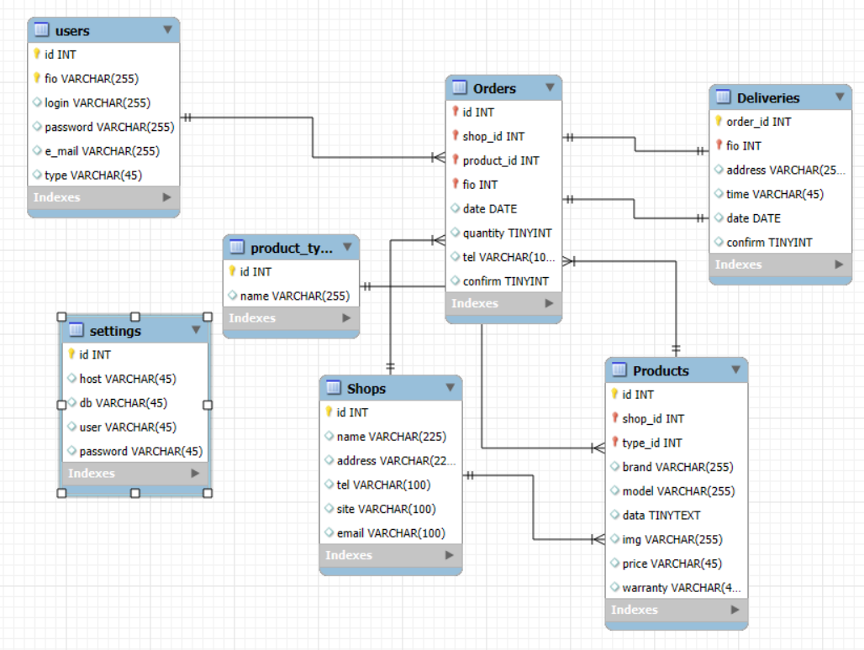

Запрос:

-- MySQL Workbench Forward Engineering

SET @OLD_UNIQUE_CHECKS=@@UNIQUE_CHECKS, UNIQUE_CHECKS=0;

SET @OLD_FOREIGN_KEY_CHECKS=@@FOREIGN_KEY_CHECKS, FOREIGN_KEY_CHECKS=0;

SET @OLD_SQL_MODE=@@SQL_MODE, SQL_MODE='ONLY_FULL_GROUP_BY,STRICT_TRANS_TABLES,NO_ZERO_IN_DATE,NO_ZERO_DATE,ERROR_FOR_DIVISION_BY_ZERO,NO_ENGINE_SUBSTITUTION';

-- -----------------------------------------------------

-- Schema mydb

-- -----------------------------------------------------

-- -----------------------------------------------------

-- Schema mydb

-- -----------------------------------------------------

CREATE SCHEMA IF NOT EXISTS `mydb` DEFAULT CHARACTER SET utf8 ;

USE `mydb` ;

-- -----------------------------------------------------

-- Table `mydb`.`users`

-- -----------------------------------------------------

CREATE TABLE IF NOT EXISTS `mydb`.`users` (

`id` INT NOT NULL AUTO_INCREMENT,

`fio` VARCHAR(255) NOT NULL,

`login` VARCHAR(255) NULL,

`password` VARCHAR(255) NULL,

`e_mail` VARCHAR(255) NULL,

`type` VARCHAR(45) NULL,

PRIMARY KEY (`id`, `fio`),

UNIQUE INDEX `id_UNIQUE` (`id` ASC) VISIBLE,

UNIQUE INDEX `login_UNIQUE` (`login` ASC) VISIBLE)

ENGINE = InnoDB;

-- -----------------------------------------------------

-- Table `mydb`.`settings`

-- -----------------------------------------------------

CREATE TABLE IF NOT EXISTS `mydb`.`settings` (

`id` INT NOT NULL AUTO_INCREMENT,

`host` VARCHAR(45) NULL,

`db` VARCHAR(45) NULL,

`user` VARCHAR(45) NULL,

`password` VARCHAR(45) NULL,

PRIMARY KEY (`id`),

UNIQUE INDEX `id_UNIQUE` (`id` ASC) VISIBLE)

ENGINE = InnoDB;

-- -----------------------------------------------------

-- Table `mydb`.`Shops`

-- -----------------------------------------------------

CREATE TABLE IF NOT EXISTS `mydb`.`Shops` (

`id` INT NOT NULL AUTO_INCREMENT,

`name` VARCHAR(225) NULL,

`address` VARCHAR(225) NULL,

`tel` VARCHAR(100) NULL,

`site` VARCHAR(100) NULL,

`email` VARCHAR(100) NULL,

PRIMARY KEY (`id`),

UNIQUE INDEX `id_UNIQUE` (`id` ASC) VISIBLE)

ENGINE = InnoDB;

-- -----------------------------------------------------

-- Table `mydb`.`product_type`

-- -----------------------------------------------------

CREATE TABLE IF NOT EXISTS `mydb`.`product_type` (

`id` INT NOT NULL AUTO_INCREMENT,

`name` VARCHAR(255) NULL,

PRIMARY KEY (`id`),

UNIQUE INDEX `id_UNIQUE` (`id` ASC) VISIBLE)

ENGINE = InnoDB;

-- -----------------------------------------------------

-- Table `mydb`.`Products`

-- -----------------------------------------------------

CREATE TABLE IF NOT EXISTS `mydb`.`Products` (

`id` INT NOT NULL AUTO_INCREMENT,

`shop_id` INT NOT NULL,

`type_id` INT NOT NULL,

`brand` VARCHAR(255) NULL,

`model` VARCHAR(255) NULL,

`data` TINYTEXT NULL,

`img` VARCHAR(255) NULL,

`price` VARCHAR(45) NULL,

`warranty` VARCHAR(45) NULL,

PRIMARY KEY (`id`, `shop_id`, `type_id`),

UNIQUE INDEX `id_UNIQUE` (`id` ASC) VISIBLE,

INDEX `shop_to_products_idx` (`shop_id` ASC) VISIBLE,

INDEX `product_to_type_idx` (`type_id` ASC) VISIBLE,

CONSTRAINT `shop_to_products`

FOREIGN KEY (`shop_id`)

REFERENCES `mydb`.`Shops` (`id`)

ON DELETE NO ACTION

ON UPDATE NO ACTION,

CONSTRAINT `product_to_type`

FOREIGN KEY (`type_id`)

REFERENCES `mydb`.`product_type` (`id`)

ON DELETE NO ACTION

ON UPDATE NO ACTION)

ENGINE = InnoDB;

-- -----------------------------------------------------

-- Table `mydb`.`Deliveries`

-- -----------------------------------------------------

CREATE TABLE IF NOT EXISTS `mydb`.`Deliveries` (

`order_id` INT NOT NULL AUTO_INCREMENT,

`fio` INT NOT NULL,

`address` VARCHAR(255) NULL,

`time` VARCHAR(45) NULL,

`date` DATE NULL,

`confirm` TINYINT NULL,

PRIMARY KEY (`order_id`, `fio`),

UNIQUE INDEX `order_id_UNIQUE` (`order_id` ASC) VISIBLE,

INDEX `deliveries_to_orders_idx` (`fio` ASC) VISIBLE,

CONSTRAINT `deliveries_to_orders`

FOREIGN KEY (`fio`)

REFERENCES `mydb`.`Orders` (`fio`)

ON DELETE NO ACTION

ON UPDATE NO ACTION)

ENGINE = InnoDB;

-- -----------------------------------------------------

-- Table `mydb`.`Orders`

-- -----------------------------------------------------

CREATE TABLE IF NOT EXISTS `mydb`.`Orders` (

`id` INT NOT NULL AUTO_INCREMENT,

`shop_id` INT NOT NULL,

`product_id` INT NOT NULL,

`fio` INT NOT NULL,

`date` DATE NULL,

`quantity` TINYINT NULL,

`tel` VARCHAR(100) NULL,

`confirm` TINYINT NULL,

PRIMARY KEY (`id`, `shop_id`, `product_id`, `fio`),

UNIQUE INDEX `id_UNIQUE` (`id` ASC) VISIBLE,

INDEX `orders_to_users_idx` (`fio` ASC) VISIBLE,

INDEX `orders_to_products_idx` (`product_id` ASC) VISIBLE,

INDEX `orders_to_shops_idx` (`shop_id` ASC) VISIBLE,

CONSTRAINT `orders_to_users`

FOREIGN KEY (`fio`)

REFERENCES `mydb`.`users` (`id`)

ON DELETE NO ACTION

ON UPDATE NO ACTION,

CONSTRAINT `orders_to_shops`

FOREIGN KEY (`shop_id`)

REFERENCES `mydb`.`Shops` (`id`)

ON DELETE NO ACTION

ON UPDATE NO ACTION,

CONSTRAINT `orders_to_products`

FOREIGN KEY (`product_id`)

REFERENCES `mydb`.`Products` (`id`)

ON DELETE NO ACTION

ON UPDATE NO ACTION,

CONSTRAINT `orders_to_deliveries`

FOREIGN KEY (`id`)

REFERENCES `mydb`.`Deliveries` (`order_id`)

ON DELETE NO ACTION

ON UPDATE NO ACTION)

ENGINE = InnoDB;

SET SQL_MODE=@OLD_SQL_MODE;

SET FOREIGN_KEY_CHECKS=@OLD_FOREIGN_KEY_CHECKS;

SET UNIQUE_CHECKS=@OLD_UNIQUE_CHECKS;

Фрагмент запроса, касающийся создания и настройки таблицы *Orders*:

CREATE TABLE IF NOT EXISTS `mydb`.`Orders` (

`id` INT NOT NULL AUTO_INCREMENT,

`shop_id` INT NOT NULL,

`product_id` INT NOT NULL,

`fio` INT NOT NULL,

`date` DATE NULL,

`quantity` TINYINT NULL,

`tel` VARCHAR(100) NULL,

`confirm` TINYINT NULL,

PRIMARY KEY (`id`, `shop_id`, `product_id`, `fio`),

UNIQUE INDEX `id_UNIQUE` (`id` ASC) VISIBLE,

INDEX `orders_to_users_idx` (`fio` ASC) VISIBLE,

INDEX `orders_to_products_idx` (`product_id` ASC) VISIBLE,

INDEX `orders_to_shops_idx` (`shop_id` ASC) VISIBLE,

CONSTRAINT `orders_to_users`

FOREIGN KEY (`fio`)

REFERENCES `mydb`.`users` (`id`)

ON DELETE NO ACTION

ON UPDATE NO ACTION,

CONSTRAINT `orders_to_shops`

FOREIGN KEY (`shop_id`)

REFERENCES `mydb`.`Shops` (`id`)

ON DELETE NO ACTION

ON UPDATE NO ACTION,

CONSTRAINT `orders_to_products`

FOREIGN KEY (`product_id`)

REFERENCES `mydb`.`Products` (`id`)

ON DELETE NO ACTION

ON UPDATE NO ACTION,

CONSTRAINT `orders_to_deliveries`

FOREIGN KEY (`id`)

REFERENCES `mydb`.`Deliveries` (`order_id`)

ON DELETE NO ACTION

ON UPDATE NO ACTION)

ENGINE = InnoDB

**Задание 3**

Операция не получилось – ошибка

